**Name:** Vineel Sai

**Reg No:** 498

**IIIT Kalyani, Assignment 2 8085 Micro controller**

**PROB.1** ONE 16 BIT NUMBER IS IN 8COOH AND 8CO1H. ANOTHER NUMBER IS IN MEMORY LOCATIONS 8C02H AND 8C03H. ADD THE NUMBERS AND STORE THE RESULT IN 8C04H AND 8CO5H.

4200 2A 00 08C LHLD 35840

4203 EB XCHG

4204 2A 02 08C LHLD 35842

4207 19 DAD D

4208 22 04 08C SHLD 35844

420B 76 HLT

**OUTPUT**

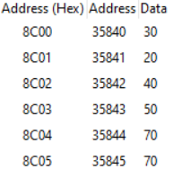

**PROB.2** 16 BYTES OF DATA ARE STORED IN MEMORY LOCATIONS FROM 8850H TO 885FH. TRANSFER THE ENTIRE BLOCK OF DATA BYTES TO NEW MEMORY LOCATIONS STARTING FROM 8870H.

4200 0E 10 MVI C, 16

4202 21 50 88 LXI H, 34896

4205 11 70 88 LXI D, 34928

4208 7E LOOP: MOV A, M

4209 12 STAX D

420A 23 INX H

420B 13 INX D

420C 0D DCR C

420D C2 08 042 JNZ LOOP

4210 76 HLT

**INPUT OUTPUT**

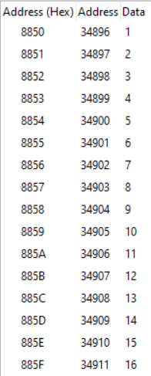 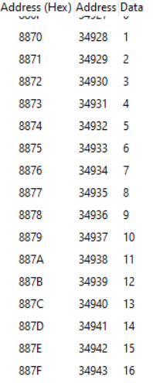

**PROB.3** 16 BYTES OF DATA ARE STORED IN MEMORY LOCATIONS FROM 8850H TO

885FH. TRANSFER THE ENTIRE BLOCK OF DATA BYTES TO NEW MEMORY LOCATIONS STARTING FROM 8870H IN REVERSE ORDER.

4200 0E 10 MVI C, 16

4202 21 5F 88 LXI H, 34911

4205 11 70 88 LXI D, 34928

4208 7E LOOP: MOV A, M

4209 12 STAX D

420A 2B DCX H

420B 13 INX D

420C 0D DCR C

420D C2 08 042 JNZ LOOP

4210 76 HLT

**INPUT OUTPUT**

 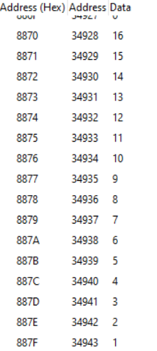

**PROB.4** 16 BYTES OF DATA ARE STORED IN MEMORY LOCATIONS FROM 8850H TO

885FH. TRANSFER THE ENTIRE BLOCK OF DATA BYTES TO NEW MEMORY LOCATIONS STARTING FROM 8855H IN FORWARD ORDER.

4200 0E 10 MVI C, 16

4202 21 5F 88 LXI H, 34911

4205 11 67 88 LXI D, 34919

4208 7E LOOP: MOV A, M

4209 12 STAX D

420A 2B DCX H

420B 1B DCX D

420C 0D DCR C

420D C2 08 042 JNZ LOOP

4210 76 HLT

**INPUT OUTPUT**

** 